2)Create a repo in github with README.md and .ignore file.

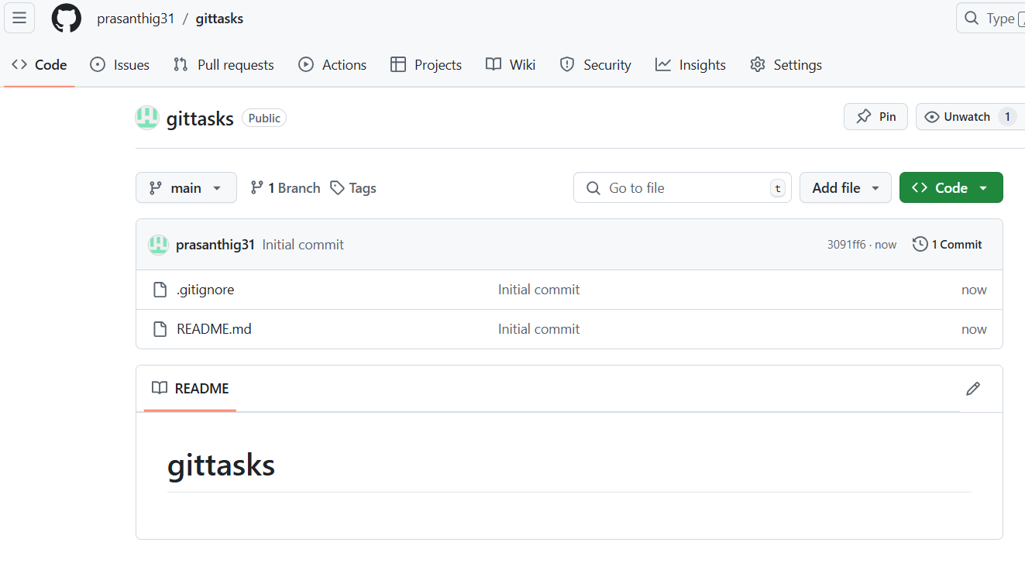

3)Clone the created repo to local.

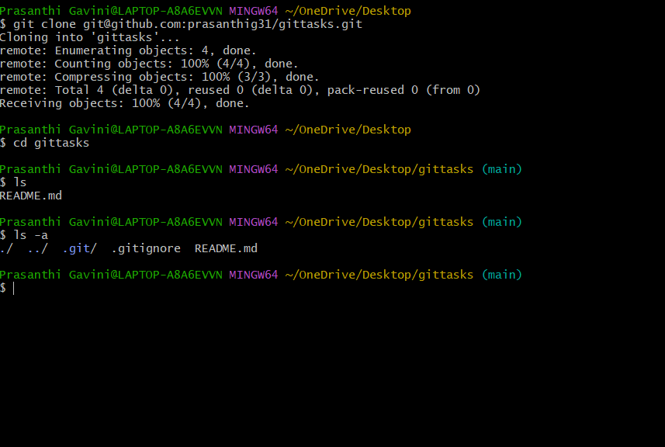

4)Create two files in local repo.

5)Commit two files and push to central Repository.

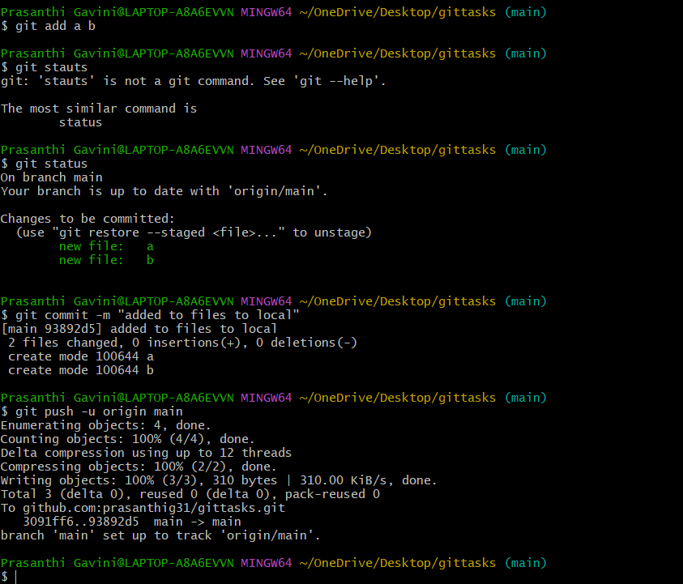

6)Create a branch in local and create a sample file and push to central.

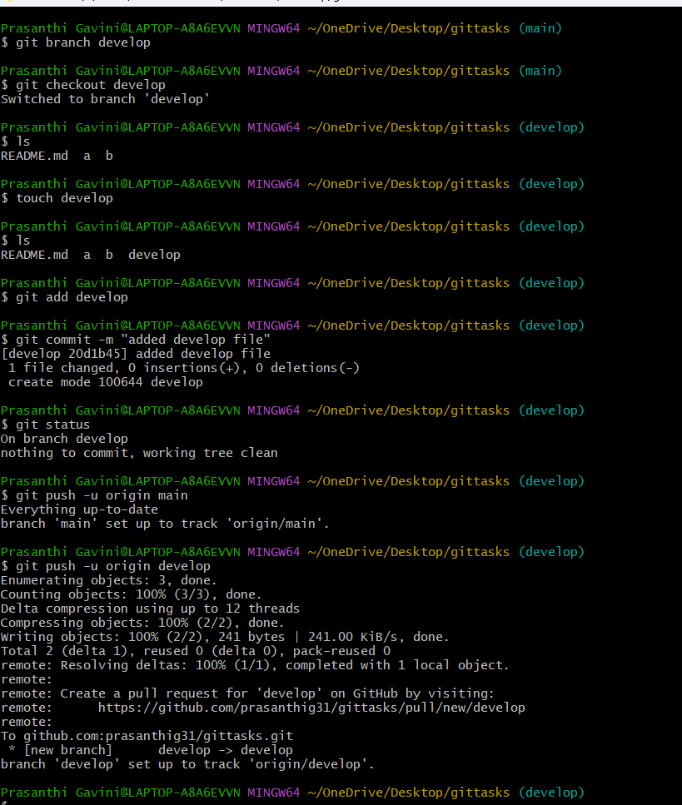

7)Create a branch in github and clone that to local.

11)clone only a branch from github to local.

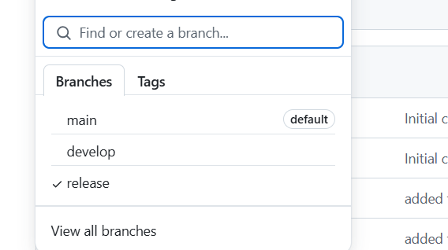

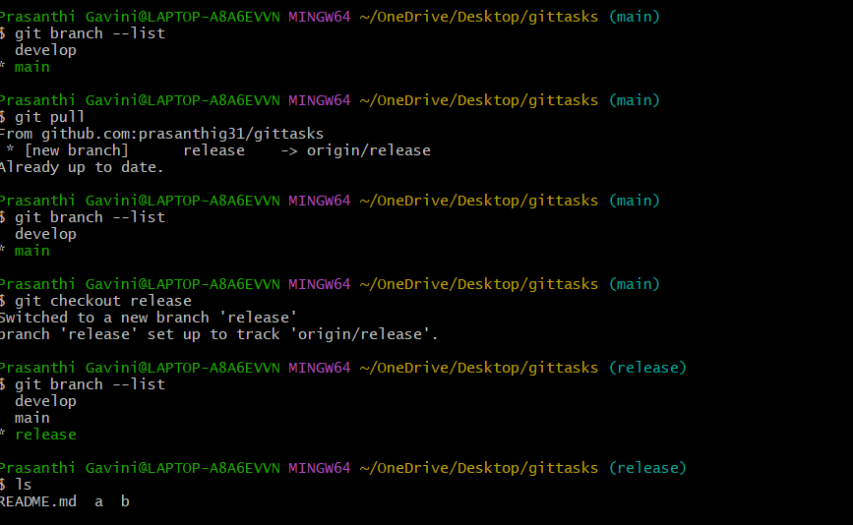

8)Merge the created branch with master in git local

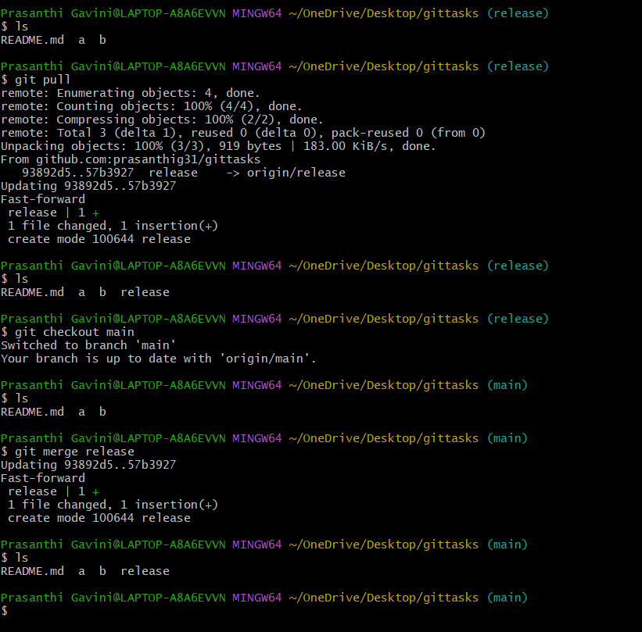

9)Merge the created branch with master in github by sending a pull request.

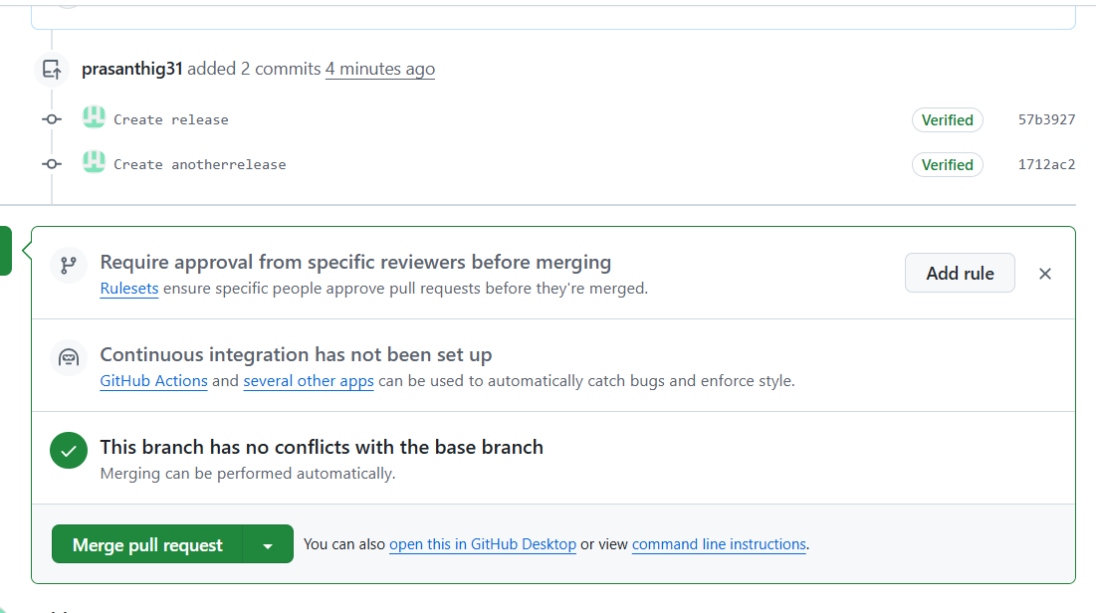



11)clone only a branch from github to local.

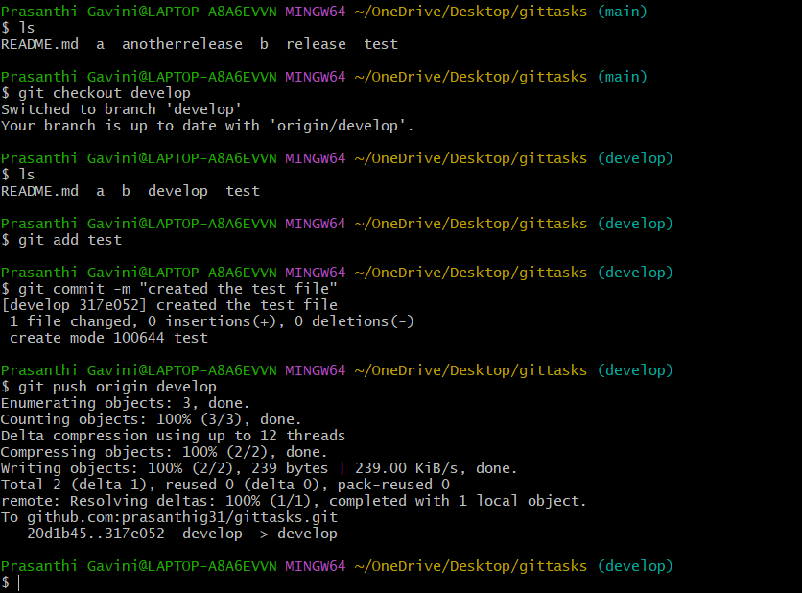

12)create a file with all passwords and make that untrackable with git.

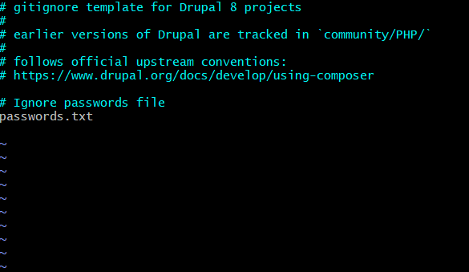

13) make a commit and make that commit reset without savings changes.

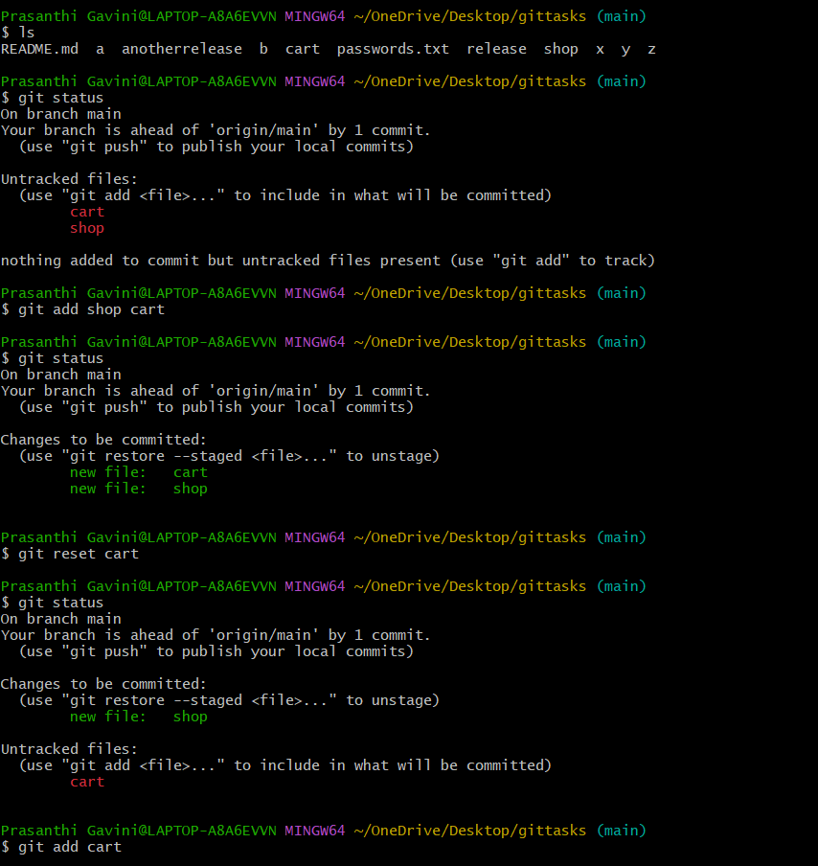

14)Revert a committed commit to the older version.

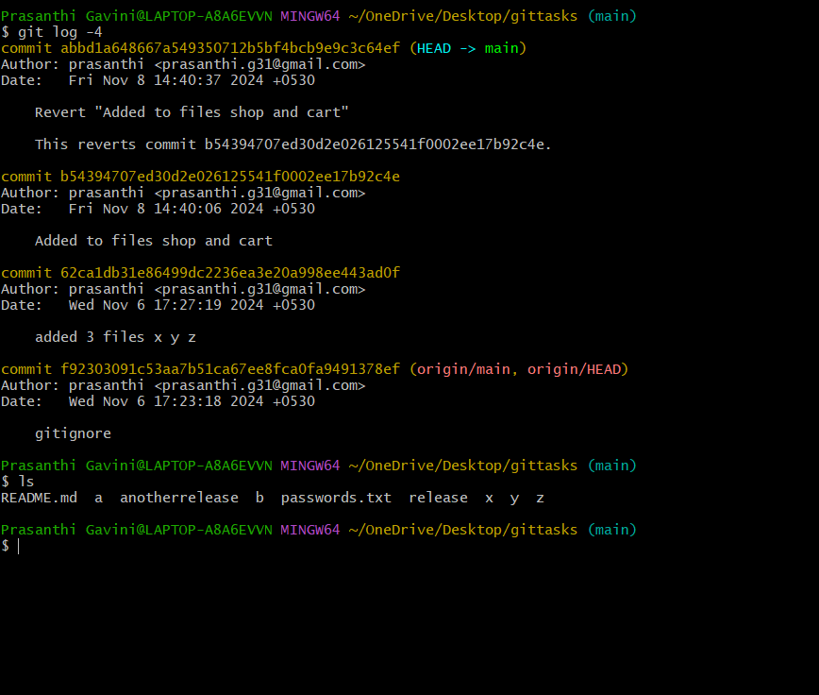

15) push a file to stash without savings the changes and work on another file.

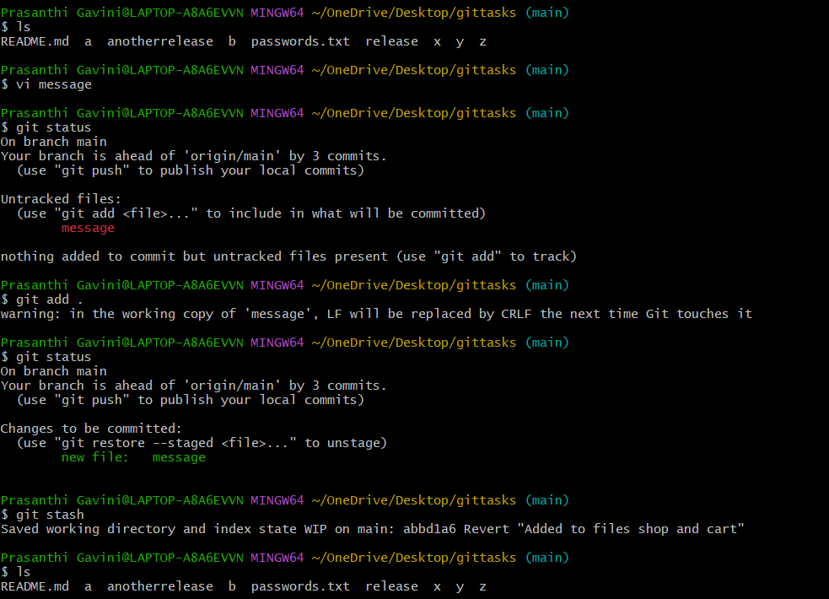

16)undo the stash file and start working on that again.

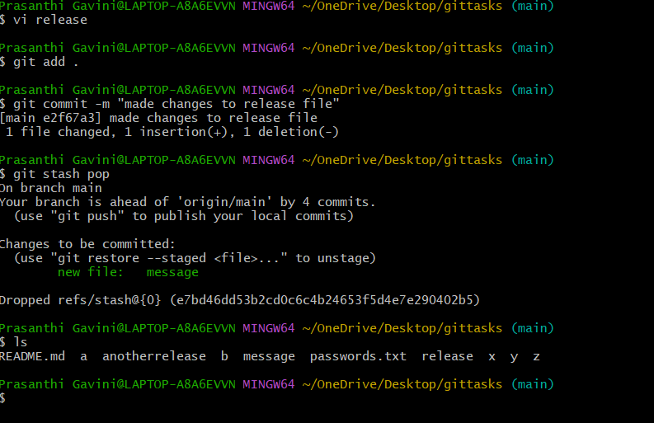

18)configure webhooks to github.

20)Check all the logs of git.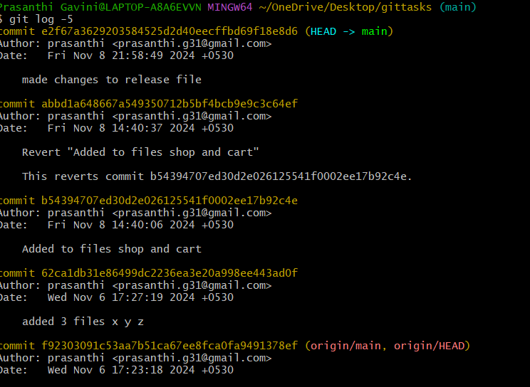

21)Rename the commit message.

22)Merge multiple commits into single commit.